Activity

NAME: SCORE:________/100

(SURNAME, GIVEN NAME M.I. )

YEAR AND SECTION: BSIT3___

Directions: Answer the following questions. For the format font style – Arial size – 12 spacing – single, alignment – justified, orientation- portrait. Assignments should be in .PDF and .DOC/.DOCX file and with header and footer. Unable to follow the directions will be given a score of zero.

1. Create a simple pyramid using Windows Form, Display your name and section and Windows Form contains Button, label, and Textbox.
2. Create Button Show, Clear and Exit.
3. User input handle by Textbox1 and for textbox2 make textbox task to Multiline and Text alignment to Center

Example:

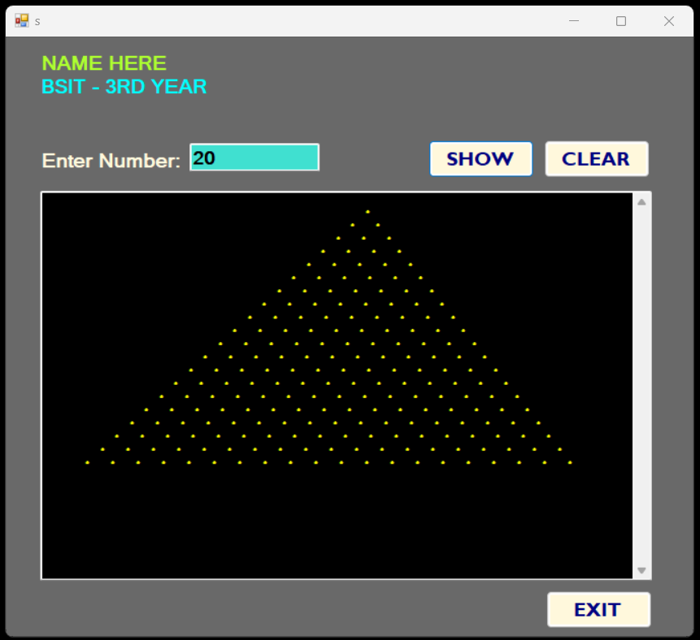

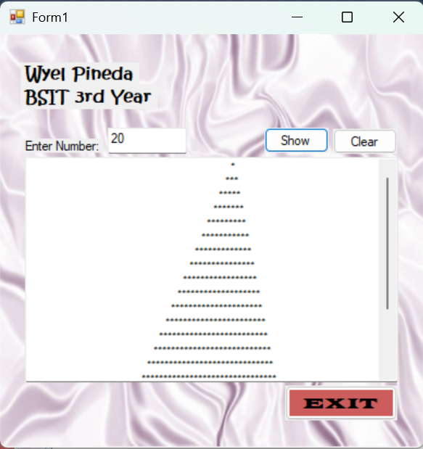

Public Class Form1

Private Sub Form1_Load(ByVal sender As Object, ByVal e As EventArgs) Handles MyBase.Load

TextBox2.Multiline = True

TextBox2.ScrollBars = ScrollBars.Vertical

TextBox2.TextAlign = HorizontalAlignment.Center

End Sub

Private Sub Button1_Click(ByVal sender As System.Object, ByVal e As System.EventArgs) Handles Button1.Click

Dim rows As Integer

If Integer.TryParse(TextBox1.Text, rows) AndAlso rows > 0 Then

TextBox2.Text = ""

For i As Integer = 1 To rows

TextBox2.Text &= Space(rows - i) & New String("*"c & " "c, (2 * i - 1)) & vbCrLf

Next

Else

MessageBox.Show("Please enter a valid positive number.", "Invalid Input", MessageBoxButtons.OK, MessageBoxIcon.Warning)

End If

End Sub

Private Sub Button2_Click(ByVal sender As System.Object, ByVal e As System.EventArgs) Handles Button2.Click

TextBox1.Clear()

TextBox2.Clear()

TextBox1.Focus()

End Sub

Private Sub Button3_Click(ByVal sender As System.Object, ByVal e As System.EventArgs) Handles Button3.Click

Me.Close()

End Sub

End Class